# INTRODUCTION

* 1. Overview

The overview of the project is to analyse the electric vehicles, their availability, different models and the supported infrastructure in India.

* 1. Purpose

The purpose is to visualise is the different brands and the options available in the electric cars.

1. **Problem Definition & Design Thinking**
   1. Empathy Map

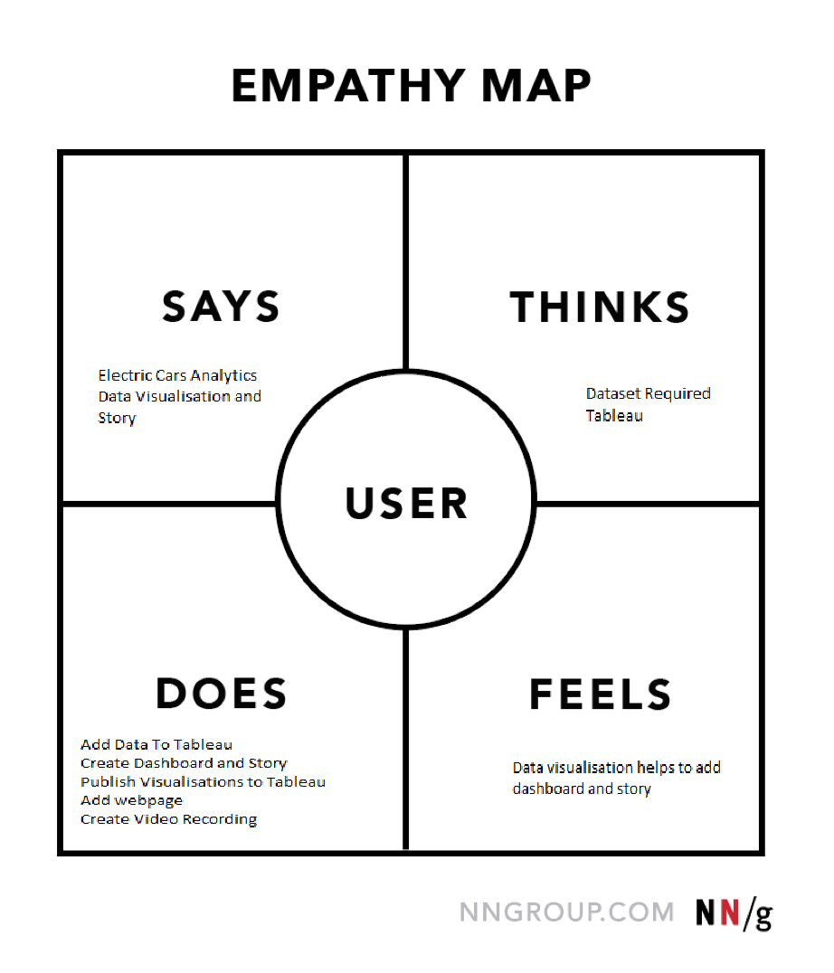

* 1. Ideation & Brainstorming Map

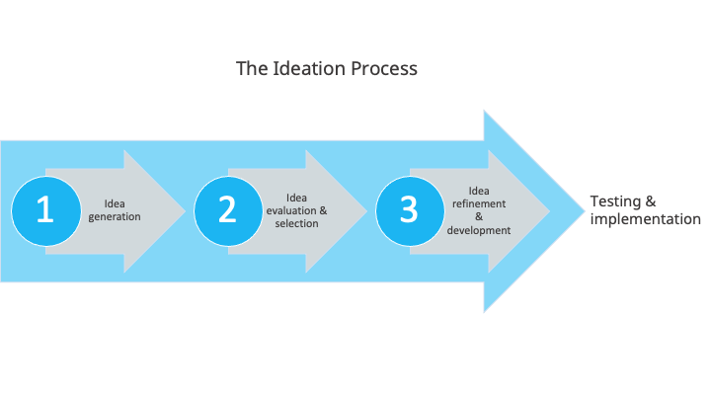

# RESULT

**Dashboard:**

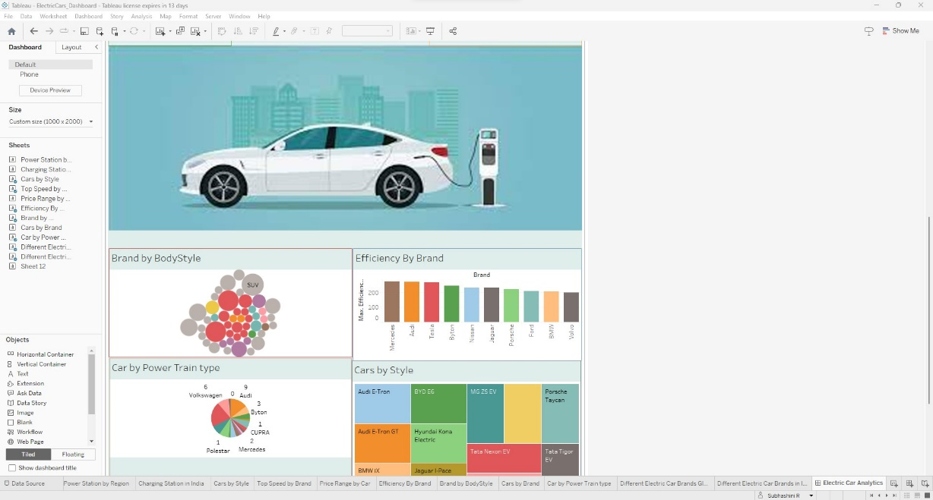

**Story:**

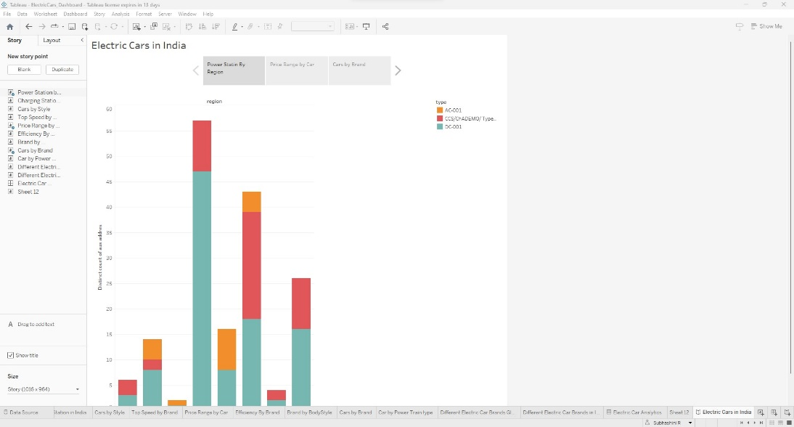

**Webpage:**

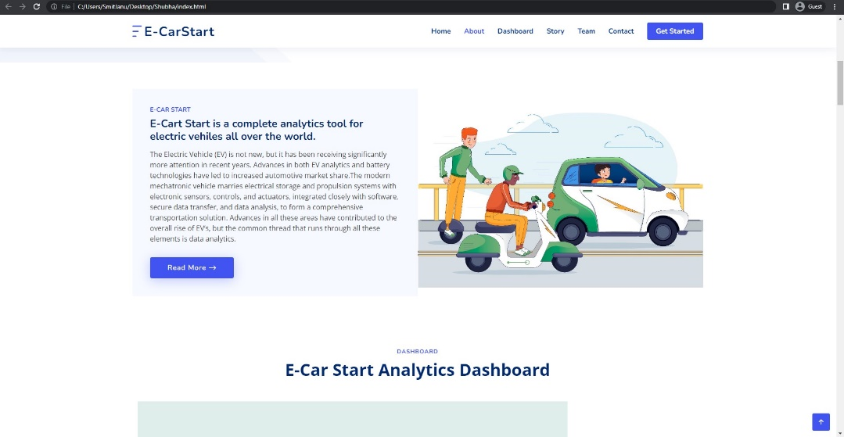

# ADVANTAGES & DISADVANTAGES

**Advantages:**

The advantages are that the electric cars are getting available in India and charging and other support are also present.

There are many different brands and options available and different power and efficiency are also present.

**Disadvantages:**

We currently have moderate options available in India and more car brands need to be present.

The charging stations need to be increased as it is present only in few places in the country.

# APPLICATIONS

The visualization can be used to identify the options available in the electric cars and to motivate the usage of electric cars.

# CONCLUSION

The electric cars have the adequate availability and infrastructure in India.

# FUTURE SCOPE

In future, further scope can be added to know about the customer experience and the performance of the electric cars, battery charging time and other relevant data to support the cause.